THE CLUB NOW HAS A COMBINATION LOCK. YOU MUST HAVE YOUR CURRENT MEMBERSHIP CARD TO OBTAIN THE COMBINATION TO THE LOCKS. Remember to spin the numbers once you open the lock

IF A MEMBER SUPPLIES THE COMBINATION TO A NON-MEMBER TO GAIN ACCESS TO THE CLUB GOUNDS. THAT MEMBER is EXPELLED PERMANENTLY FROM THE CLUB.

DO NOT FORGET TO HAVE YOUR MEMEBERSHIP CARD ON YOU WHEN AT THE CLUB GROUNDS.

ISA is seeking a person for the position of Club PR, this person coordinate events with the Newspaper and responsible for photographing club events. IF YOU HAVE OR CAN CONTACT A COMPANY THAT WOULD MAKE A DONATION FOR THE HUNTING TRAPPING EDUCATION CLASSES PLEASE DO SO. WE ARE LOOKING FOR AT LEAST 100 to 200 ITEMS FOR THE KIDS.

NRA GRANT APPLICATION – applications for grant money are available on the NRA website, the application must be completed by Sept 2011 for 2012.

Porcupine is now open year round. Quills are going for $25 an ounce.

Rep Tim Krieger’s web site http://krepkrieger.com/ he has a number of items that should be of interest to club members.
Senator Kim Ward http://senatorward.com/
Rep. George Dunbar http://www.repdunbar.com/
Rep. Mike Reese http://www.repreese.com/

Castle Doctrine is now law; on August 28, the law will take effect.

There is a confirmed case of a beaver attaching a man fishing. After the attack, the beaver the trapped beaver tested positive for rabies. Friday

LOOKING TO BUY

ITEMS FOR SALE:
Kevin Nicol 724-744-7539
3 - .22 Hand guns
Tarus M970 revolver - $325
ISSC Semi (3 magazines) - $280
Chiappa 1911 Semi (hardly used)

3 - .22 Long guns
Winchester model 77 semi auto 85% condition-$250
Stevens model 860C /bolt action tube feed - $100
Nobel model 33A pump action tube feed - $125

Ralph Rock 724-454-2116
Compound Pro Hunter Hoyt Bow; never used; hardback case, full accessories. $450 or BO.

Fritz Simola 724-527-5233
Summit Viper Ultra Tree stand $175
Ladder Lounger with accessories $200

Jim Veich 724-261-2864
223 cal. Bbl for Thompson Contender; 10” bull bbl with weaver rail mount for scope or red dot. $150.00

Thompson Center 50 caliber Flintlock for sale:
This a “kit gun” originally purchased back in 1980. Patch box inlayed in he stock, all brass furniture double set triggers. T/C fiber optic adjustable rear sight & blade from sight. 1-48 twist barrel. Gun is in good shape except for a crack in the stock, which was hypodermic glued. Call 724-744-4192 or email davidteems@gmail.com

Denise McTiernar 724-689-7818
Ruger 77 Mark II .308 4X12 Leopold Scope. Loading dies and 140 rounds of brass. $625.00

Lou D'Emilio 724-744-4562
Remington Lightweight Special Field Pump; 20 gauge, 21 inch barrel, multi choke, English Stock (NEW in box)
Use or collect. Last produced in early nineties $ 695
Beretta 686 Onyx; 20 gauge o/u, 26 inch barrels, multi choke (Excellent) $1275
Ruger Security-Six 357 Magnum/38 Sp.; Stainless, four-inch barrel (Excellent) $399

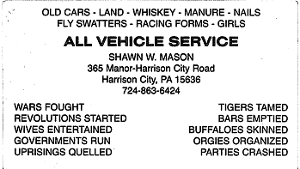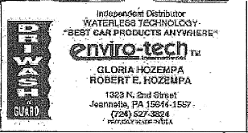
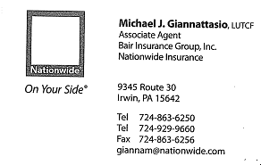
Chuck Konkus PLC’s Motor Control
Sales Representative Enclosures, Wire & Cable,
Industrial Division Lighting Design

SCOTT ELECTRIC
Wholesale Electrical Distributor
1000 S. Main St. Greensburg, PA 15601

Phone: 1-800-442-8045 Cell Phone: 412-389-9181
Fax: 1-866-884-5152 ind@scottelectricusa.com
Guns – Jewelry – Coins – Gold – Silver –Collectibles

Licensed FFL Dealer

Tri State Pawn
(724) 515-5376

7750 Route 30 – North Huntingdon, PA 15642
Kenn Cahasia
Jeannette, PA

K.C. Express Vending
Soft Drinks – Snacks – Candy – Coffee
“Fast service for all your vending needs”
(724) 527-5233 or (724) 523-4275
A NAME YOU CAN TRUST

